**Week6 React HandsOn**

**2. ReactJS-HOL**

Create a react app for Student Management Portal named StudentApp and create a component named Home which will display the Message “Welcome to the Home page of Student Management Portal”. Create another component named About and display the Message “Welcome to the About page of the Student Management Portal”. Create a third component named Contact and display the Message “Welcome to the Contact page of the Student Management Portal”. Call all the three components.

Folder Structure

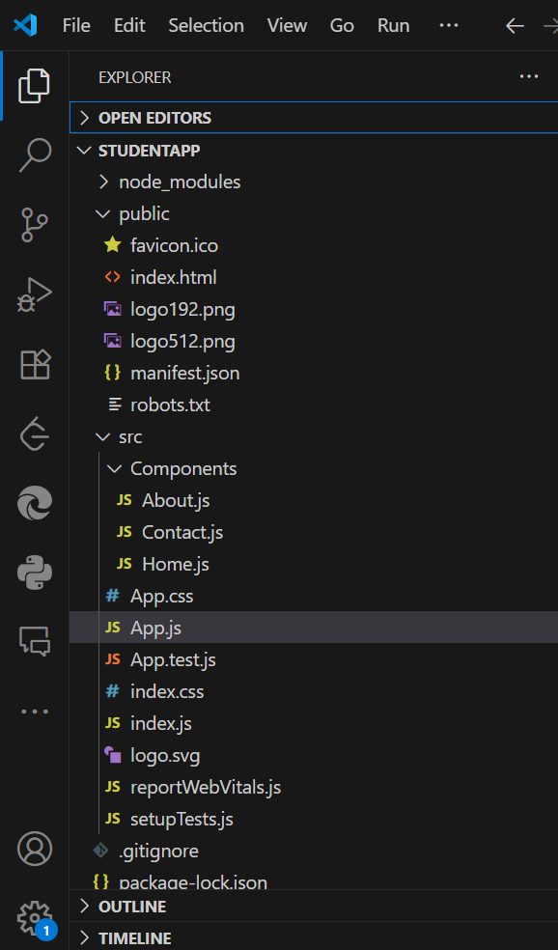

**App.js**

import './App.css';

import Home from './Components/Home';

import About from './Components/About';

import Contact from './Components/Contact';

function App() {

  return (

    <div className="Container">

      <Home />

      <About />

      <Contact />

    </div>

  );

}

export default App;

**Components/About**

import React, { Component } from 'react';

class About extends Component {

    render() {

        return (

            <div>

                <h3>Welcome to the About Page of Student Management Portal</h3>

            </div>

        );

    }

}

export default About;

**Components/Contact**

import React, { Component } from 'react';

class Contact extends Component {

    render() {

        return (

            <div>

                <h3>Welcome to the Contact Page of Student Management Portal</h3>

            </div>

        );

    }

}

export default Contact;

**Components/Home**

import React, { Component } from 'react';

class Home extends Component {

    render() {

        return (

            <div>

                <h3>Welcome to the Home Page of Student Management Portal</h3>

            </div>

        );

    }

}

export default Home;

**Output:**

PS C:\Users\umaya\Desktop\-Cognizant-Nurture-4.0-practice\Week6\StudentApp> npm start

> myfirstreact@0.1.0 start

> react-scripts start

(node:13556) [DEP_WEBPACK_DEV_SERVER_ON_AFTER_SETUP_MIDDLEWARE] DeprecationWarning: 'onAfterSetupMiddleware' option is deprecated. Please use the 'setupMiddlewares' option.

(Use `node --trace-deprecation ...` to show where the warning was created)

(node:13556) [DEP_WEBPACK_DEV_SERVER_ON_BEFORE_SETUP_MIDDLEWARE] DeprecationWarning: 'onBeforeSetupMiddleware' option is deprecated. Please use the 'setupMiddlewares' option.

Starting the development server...

Compiled successfully!

You can now view myfirstreact in the browser.

Local: http://localhost:3000

On Your Network: http://192.168.140.50:3000

Note that the development build is not optimized.

To create a production build, use npm run build.

Local: <http://localhost:3000>

On Your Network: <http://192.168.140.50:3000>

Note that the development build is not optimized.

To create a production build, use npm run build.

On Your Network: http://192.168.140.50:3000

Note that the development build is not optimized.

To create a production build, use npm run build.

Note that the development build is not optimized.

To create a production build, use npm run build.

webpack compiled successfully

